*Lovely Professional University*

*Phagwara , Punjab*



*Synopsis:*

*Course Code- CSE326*

*Submitted to- Ishan Kumar*

*Title- Electricity Bill Counter*

*Section-K19KP*

*GROUP STUDENTS:*

*NAME: REG NO. ROLL NO.*

*Nancy Srivastav 11905445 39*

*Ayush kumar 11905428 37*

*Vikram Mahajan 11905434 38*

*Introduction:*

This website will contain all the necessary information for the new user.

* Pay your bill.
* Consumption History.
* Nearest Service.
* New Connection.

The website will also have various tabs . Such as..

* Home
* About
* Contact us

In 2nd quarter of the page it will be showing that how we can pay our electricity bill and next to that it will show our electricity bill history.

We covered

* Html
* Implementing CSS
* Fonts, colors, etc
* Backgrounds & Borders
* Box Model/Margin & Padding
* Floating & Alignment
* Display property
* Link & Button Styling
* Creating Menus
* Dev tools

*Work Division:*

*AYUSH KUMAR:*

*Reg no. : 11905428*

*Help in designing the Front page and written its code for the electricity bill counter.*

*NANCY SRIVASTAV:*

*Reg no. : 11905445*

*Help in managing and preparing the writing section(synopsis and final report)coding for drop down list for FAQs.*

*VIKRAM MAHAJAN:*

*Reg no. : 11905434*

*Help in the coding section for links and read more table*

First, we write the header file

The <head> tag contains metadata (document title, character set, styles, links, scripts), specific information about the web page that is not displayed to the user. Metadata provides browsers and search engines with technical information about the web page.

The <head> includes the following elements:

* The <title> tag defines the title of a web page (required).
* The <h1> tag specifies the title of page content, whereas the <title> tag is metadata representing the title of the entire HTML content and not its content.
* The <style> tag contains CSS code that defines how HTML elements should be rendered in a browser.
* The <link> tag defines the relationship between the current HTML document and the resource to which it refers, or contains a link to an external style sheet. It can have two attributes: rel="stylesheet" and "href".
* The <meta>tag provides additional information (metadata) about HTML document. The <head> of a page can include different kinds of <meta> elements that may contain "name" and "content" attributes.

<style>

#more {display: none;}

nav .topnav{

font-size : 20px;

}

.accordion {

background-color: #eee;

color: #444;

cursor: pointer;

border: 6px solid rgba(20, 17, 17, 0.829);

padding: 0px;

width: 250px;

height:40px ;

width: 200px;

margin-left:0px;

text-align: left;

outline: none;

font-size: 25px;

transition: 0.5s;

}

.active, .accordion:hover {

background-color: rgb(180, 65, 36);

}

.panel {

padding: 0 10px;

display: none;

background-color: rgba(255, 255, 255, 0.288);

overflow: hidden;

}

</style>

The .class selector selects elements with a specific class attribute.

To select elements with a specific class, we write a period (.) character, followed by the name of the class.

we can also specify that only specific HTML elements should be affected by a class. To do this, start with the element name, then write the period (.) character, followed by the name of the class

if we want to add style to a particular style we need to use class.

Here In the above code we have used hover

We used the class to which we want to add hover

The :hover selector is used to select elements when you mouse over them.

The :hover selector is used to select elements when you mouse over them.

.active, .accordion:hover {

  background-color: rgb(180, 65, 36);

}

As soon as our courser goes tote component of above-mentioned class

Its background colour changes to the mentioned colour.

*NEAREST SERVICE: From this the user can find out the nearest place for their payment . They dont want to go directly to the electricity bill counter , they can also pay through the nearest servive center.*

*NEW CONNECTION: From this we can know about the new connection and also about the electricity bill and the information about the whole page.*

*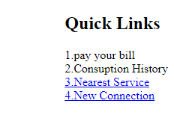*

*We have used some tabs like:*

*HOME: From this tab we can see the home page where various options are there and the full screen will show and from there we can pay the our electicity bill.*

*ABOUT: From this tab we can know each and everything about this website and also about the electricity bill . All information would be provided from this tab .*

*CONTACT US: From this tab we can contact our electricity bill counter person and can take all the information about their queries related to the bill and and all problems would be solved.*

*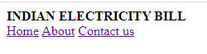*

*In this website , online method of electricity bill counter the user can pay their bill by just clicking the option "Pay your Bills" and also they can see their payment history on just clickiing on the "Consumption History".*

*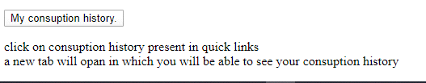*

*And after that we will see our payment history like this:*

*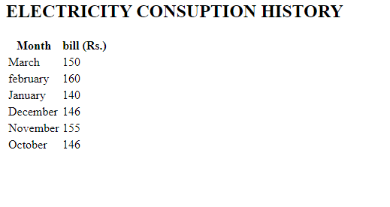*

*In this website there are different information about the new user .*

*PAY YOUR BILL: In this option the user can pay there bill . From this the new user can fill all the required information and pay their bill by the online method and the payment would be sucessfully done.*

*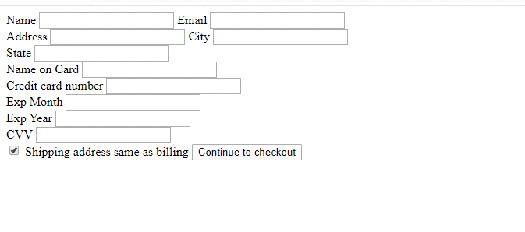*

*CONSUMPTION HISTORY: From this option , the user is able to see there consumption history that means how much electricity they have consumed till date and also further information.*

**

*NEAREST SERVICE: From this the user can find out the nearest place for their payment . They dont want to go directly to the electricity bill counter , they can also pay through the nearest servive center.*

*We had targeted the log in container button using the codes below.*

.login-container button {

      float: left;

      padding: 6px 10px;

      margin-top: 8px;

      margin-right: 16px;

      background-color: rgba(125, 196, 214, 0.973);

      color: white;

      font-size: 17px;

      border: none;

      cursor: pointer;

    }

If we want a curve edges of the box, we can use the following code

  border-top-left-radius:10px;

      border-top-right-radius:10px;

sereen short of the project

